**CO5 PROGRAMS**

**CO5_1**

f1=open("secfile.txt","w")

f1.write("This is my first file in python.\n want to work with files \n This is my third line")

f1=open("secfile.txt","r")

ff=f1.readlines()

print(ff)

**OUTPUT**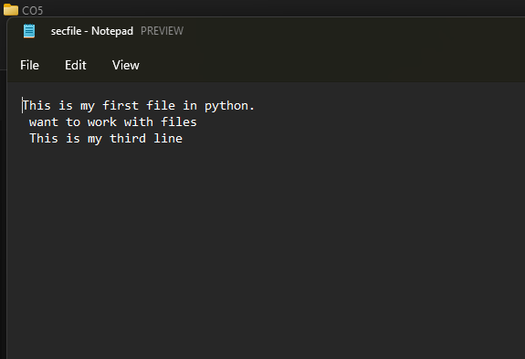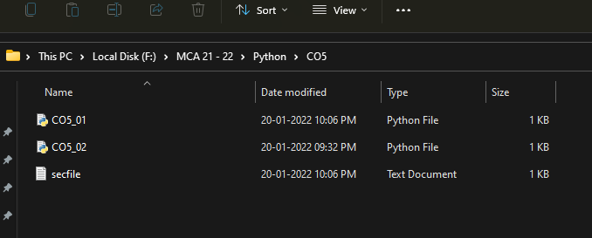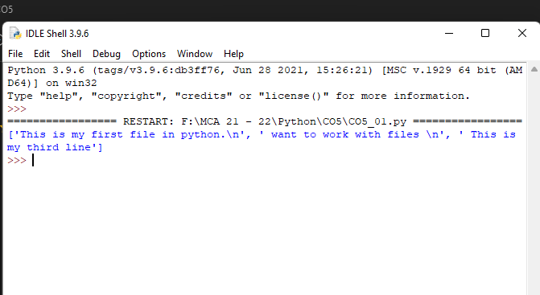

**CO5_2**

f1=open("secfile.txt","r")

ff=f1.readlines()

with open("odd.txt","w") as f2:

for x in range(0,len(ff)):

if(x%2!=0):

f2.write(ff[x])

**OUTPUT**